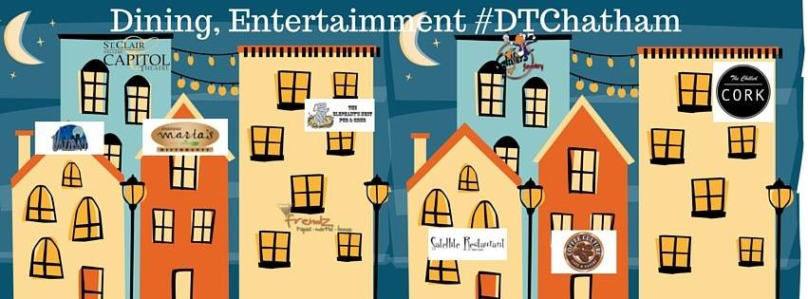
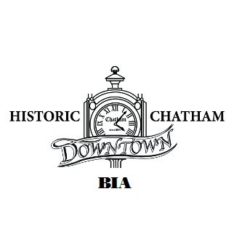
www.downtownchatham.com Spring and Summer 2017
Board of Management
- CHAIR – Jim Carrington, Collin’s Formal Wear Chatham
- Co-CHAIR – Paul Shettell, Downtown Deli.
- TREASURER- Jeff Comiskey, All Risks Insurance
- Board Members:
Nancy Labadie, Clair Culliford, Courtney Wells, Ben Fieldhouse, and Lesley Grand. Council Member-Brock McGregor; CK Police Rep-Sergeant Jim Lynds; Office Admin/Project-Coordinator-Connie Beneteau; and Bookkeeper, Michelle Houtmeyers.
Comments from the Chair – Jim Carrington:
We look forward to continued growth in our downtown and promise of a better tomorrow. Plans are well underway for our RetroFest week-end and The Downtown in the City Extravaganza committee is gearing up for our second annual event. Sponsors, volunteers and input are essential to the success of this fun night out. Any help, is always welcome. The Sons of Kent Brewery in the former Cinema Six are driving full steam ahead with a soft opening scheduled in the near future. We can look forward to the completion of the Fifth Street bridge and new sidewalks in our downtown! We wish everyone all the best for an amazing year in an amazing downtown. If we can be of any assistance within our power, please call on us.

SUMMER OF CONSTRUCTION: See page #2
UPCOMING EVENTS DOWNTOWN CHATHAM for 2017:

Pitch-In Canada: April 22nd to the 29th.
The focus of this beautification project is to clean up the “Parkland, Greenbelts and Downtown Areas” throughout the Municipality of Chatham-Kent. The HDTC-BIA and other volunteers will go around and cleaned up litter, clean out our ash pots, and refill them with sand. If your group or business would like to participate in C-K Pitch In Canada Week project, please gather up a group of volunteers and contact the BIA office. We can clean up the downtown together!

Dance Competitions at the Capitol Theatre:
March 23-26 Shine Dance Competition
April 1-2 Champions Dance Competition
April 7-9 EnPointe & Just Dance Competition
April 22-23 The Dance Rage Competition
May 6 – 7 Move with the Beat Dance Competition
RetroFest™ May 26 & 27, 2017
Friday May 26, is the ever popular
OLG Classic Car Cruise which leaves the
John D. Bradley Centre at 6pm and reaches
downtown Chatham at approximately 7pm.
Families will line the streets to watch all the cars loop King Street.
Saturday May 27: The streets will be closed by 5am. It is recommended that you post a notice in your business one week ahead of the event for your customers.
Kent Historic Auto Club Car Show pre-registration on-line on the website www.downtownchatham.com and at King St W. and 5th Street at 9am. Cars must be 25 years or older to participate.
Optimist Club of Chatham and the HSRA brings you the Soapbox Derby. Registration on William Street will begin at 9am.
Looking for Junior Judges who will judge and award their own awards.
Live entertainment in Tecumseh Park from 11am until 11pm both Friday and Saturday by Glassford Productions.

The Maple City Classic Car Auction www.ccpauctions.com

Downtown in the City Monthlys- We are looking at changing the name to: This event will run the 3rd Friday of the Month keeping the participating stores open later from5pm until 8pm with a themed night and specials for the shoppers. These will start May through November 2017. Follow us on our Facebook page: https://www.facebook.com/downtowninthecity/ and website for details.

Downtown in the City ~ Extravaganza
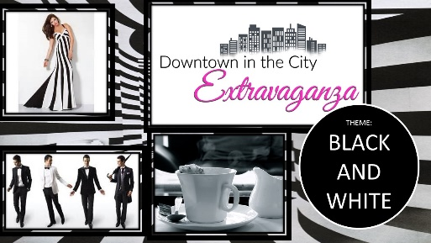
2016 was our first year for the Extravaganza and it was so much fun that we are doing it again this year. Mark your calendars for September 15, 2017 and keep informed on our Facebook page: https://www.facebook.com/Downtown-in-the-City-Extravaganza-803899539754460/

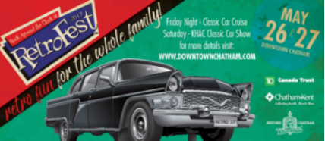

Some of the sponsors for RetroFest™ 2017 are: OLG, ENGIE, RM_Sotheby’s, Community Partnership Funding, YA Canada, TD Canada Trust, MicroAge, Sunlife Insurance, Popper’s Kettle Corn, CKXS FM 99.1, and others are still coming in. You can view a full sponsor list on our website: www.downtownchatham.com
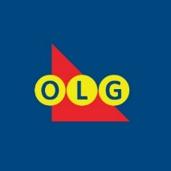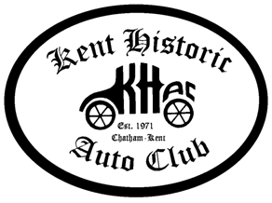
In-kind or in service: Thames Communication, Dover Port-a-John, CK John D Bradley Convention Centre, Tim Hortons, Benningers, Chatham Towing, Abstract Marketing, Downtown Deli, All-Risks Insurance, Hagerty, Optimist Club of Chatham, Subway-Chatham.

Call or email if you would like to be a sponsor and keep this great event happening!

Downtown in the City Monthly’s- We are looking at changing the name. This event will run the 3rd Friday of the Month keeping the participating stores open later from 5pm until 8pm with a themed night and specials for the shoppers. These will start June through November 2017. Follow us on our Facebook page: https://www.facebook.com/downtowninthecity/ and website for details.

Downtown in the City ~ Extravaganza
2016 was our first year for the Extravaganza and it was so much fun that we are doing it again this year. Mark your calendars for September 15, 2017 and keep informed on our Facebook page: https://www.facebook.com/Downtown-in-the-City-Extravaganza-803899539754460/

Constructions Updates for 2017 Downtown Chatham:
5th Street bridge report:
Staging for the 5th Street Bridge replacement will begin on the Northside in the parking lot#2. This area will be repurposed for the construction equipment starting in May. There will continue to be limited parking available. By Monday June 5, 2017 the Bridge will be closed from Thames Street to 5th Street at King. This will be in effect until December 31, 2017. Also as part of this process, the entire intersection at King and 5th, AODA Standards (Accessibility Standards = New signals, pavement markings and etc.) Updates will be sent out by email only, as they progress.
Sidewalk replacement:
This summer (July & August) there will be 8-10 weeks of construction for new plain concrete sidewalks in the downtown core. The Tender will be issued in March and construction will begin the first week of July (after the Canada Day Parade). The current plan is to do the construction in sections, block by block. Possibly starting with the north side first then moving to the south side. Most sections of King Street from Third to Adelaide will be replaced, also Forth and Sixth Street will be completed at the same time. During this construction, Canada Post will be looking at alternatives for mail delivery. The benches and garbage receptacles will be temporarily removed and replaced after construction. Updates will be sent out by email only, as they progress.
The construction company will ensure access into your businesses. We encourage everyone to be creative to help keep patrons coming downtown during this process.
IMPORTANT LINKS
BIA By-law:
The Historic Downtown Chatham BIA as well as all the other 6 BIAs within the Chatham-Kent area are governed by the Chatham-Kent Municipal BIA By-law that was passed March 23, 2015. The new by-law governs the actions and relationships of all the BIA’s in the Municipality of Chatham-Kent.
♣Municipality of CK BIA By-law 38-2015 BIA By-law
http://www.chatham-kent.ca/bylaws/Pages/default.aspx

OTHER IMPORTANT LINKS
♣Municipal Act on BIAs Section 204
http://www.e-laws.gov.on.ca/html/statutes/english/elaws_statutes_01m25_e.htm#s204s1
♣BIA HANDBOOK

http://www.mah.gov.on.ca/Page1529.aspx

Mark your calendars:
- April 22-29 Pitch In Week
- May 17-19 Heart & Stroke Big Bike Ride
- May 26 & 27 RetroFest
- June 3 Optimist Club Festival of Youth
- June 4 Walk a Mile in Her Shoes
- June 16 DTIC-theme
- June 30 & July 1 Canada Day
- July 7-9 Ribfest
- July 21 DTIC-theme
- Aug 18 DTIC-theme
- Aug. 25 & 26 Bikefest
- Sept. 15 DTIC~Extravaganza
- Sept. 22 & 23 FireFest
- Oct 18 DTIC-theme
- Nov. 17 Santa Claus Parade?

- Next Newsletter will be published in August 2017. If you want to insert a flyer, please contact the office bia@bellnet.ca

Let’s talk about our Downtown Chatham Santa Claus Parade….. We are looking for volunteer committee members who would like to take over this activity. If your group is interested, please don’t hesitate to give us a call at 519-352-8387.

Changes in Businesses Downtown:

Floating Therapy:
268 King St. W
(519) 397-4221

Baba ‘n Me
11 Third St.
(519) 360-7164

Foot Obsession inside DCC
100 King St. W

The Veranda moved:
165 King St. W.
226-626-3749
enquire@theveranda.ca

King Street Pawnbrokers Added EZ Vape to their inventory.
210 King St. W
(519) 354-4920

One Up Communication in with Nest Realty
Katie Zimmer-Vilaranda
71 King St. W.
(519) 359-0604

All Kindz of Kopies moved to: 158 King St. W

City Lights Hair Salon moved to: 44 Fourth Street

Liberty Tax moved to: 62 Fourth St.

St. Clair Insurance moved to:
58 Fourth St.

The Scrub Shop: moved into
159 King St. W 519-397-4613

Hooper’s Martial Arts moved into:
101 King St. W

Coffee Culture building: Apollo looking to lease

DEVOS Furniture 14 King St. W – more details to come.

JCP Design – renovating into 2 new store fronts available this Fall.

If you have any business listing updates, please email info@downtownchatham.com

Visit our website at
http://downtownchatham.com/
Follow us on Twitter: https://twitter.com/ChathamBia

Like us on Facebook at
https://www.facebook.com/pages/Historic-Downtown-Chatham-BIA/193303627374216
Also:
https://www.facebook.com/Retrofest?ref=tn_tnm

Use the hashtag: #DTChatham
On all your social media

Parking on the streets:
We would like to continue encouraging merchants, owners, and staff not to park on main street if possible. This leaves spaces available for are available for customers.
A map is included to show your customers where there is parking available.

Council members for your Ward 6 – Chatham
- Darrin Canniff
- Michael Bondy
- Doug Sulman
- Derek Robertson
- Bob Myers
- Brock McGregor: BIA Council Representative.

If you need to contact either the Mayor or the Council members, call the Civic Centre 519-360-1998 or email all Councilors council@chatham-kent
You too can add your advertising to our next newsletter.
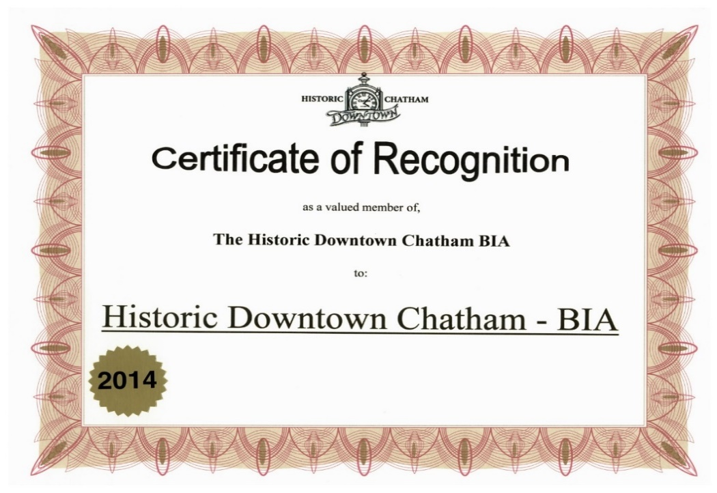

If you have a certificate, please add your 2017 sticker here. If you do not and wish to request a certificate of recognition to the Historic Downtown Chatham BIA, please contact the office at
519-352-83878 or email us at bia@bellnet.ca and we will get one out to you.
2017
2016
2015

