|  |  |  |  |  |
| --- | --- | --- | --- | --- |
| Fall_Winter news pic.jpg |  | |  | | --- | | **Historic Downtown Chatham ~ BIA**  Newsletter 2015/16 Fall/Winter | |  | |
|  |  |  |
|  |  |  |

**UPCOMING EVENTS DOWNTOWN CHATHAM for 2015 / 2016:**

**Santa Claus Parade Nov. 20th**

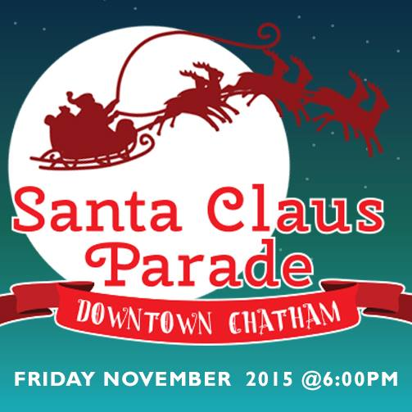

This year the Chatham Santa Claus Parade has been moved out a week to better fit in the Remembrance Day activities and getting ready with the Christmas decorations.

Bundle up the family as GDF Suez have partnered with the Downtown Chatham Centre and the Historic Downtown Chatham~BIA to hosts this year’s Santa Claus Parade on November 20th, 2015 at 6:00 pm.

Want to enter a float in this year's Santa Claus Parade?   
Don't wait email jaclyn@downtownchathamcentre.ca for your form today!

Parade Route: The parade will form up on Sandy Street, travel south over the Lacroix Street bridge, east onto King Street West to the Wish Centre.

There has been a Facebook page created so you can keep up to date with current activities. Like and Share this page:

<https://www.facebook.com/DTChathamSantaParade>

****

**Shop the Neighbourhood.**



On **November 28th**, 2015, Canadians nationwide will be encouraged to make a local purchase and take advantage of exclusive event day deals offered by the businesses in their neighbourhood. There are currently over 320 Business Associations participating in this year’s program and over 3,400 businesses across Canada have already registered (as of Oct. 7, 2015).

Become a participating business in 3 easy steps! It’s 100% free and 100% great for business. To register, copy and paste into your browser. <http://register-shoptheneighbourhood.yp.ca/>

#shopthehood

Questions? Shop The Neigh- bourhood team is here to help at [shoptheneighbourhood@yp.ca](mailto:shoptheneighbourhood@yp.ca) or at 1 844 YP-LOCAL.

**HDTC-BIA Annual General Meeting:**

Each year for our Annual General Meeting for the Historic Downtown Chatham~BIA, we make an effort to always have our meetings within our membership area. Each year we try to alternate between a dinner meeting and a breakfast meeting. This year the AGM will be held at the **Tasty Lunch.** 79 King St. West, Chatham, ON

*Lori Parker has owned and operated The Tasty Lunch restaurant for over 10 years.  The restaurant was first opened in 1934. Lori uses the same approach each and every day: treat customers like family with honesty and integrity.*

DATE & TIME:

**November 23rd**, 2015

Breakfast at 8:00 a.m., meeting commences at 8:30 a.m. All welcome. Please RSVP by Nov. 16th 2015 email: [info@downtownchatham.com](mailto:info@downtownchatham.com) or call the office 519-352-8387

**New Board Members Needed!**

Are you interested in becoming a board member? All businesses in the area, whether professional, dining, entertainment, finance, or retail benefit from the improvement that a successful BIA helps to create. You can help to improve your Downtown Chatham by sitting on the board.

**Volunteer for Events**

Anyone who would like to volunteer for any event, please call the HDTC-BIA Office or email [info@downtownchatham.com](mailto:info@downtownchatham.com)

**Sponsors for Events**

Anyone or any business who would like to sponsor an event, please call the HDTC-BIA Office or email [info@downtownchatham.com](mailto:info@downtownchatham.com)

**Parking on the streets:**

Due to the Christmas Holiday Season approaching, we would like to ensure parking spaces are available for the Customers. Please encourage Staff (and Owners) not to park on the main street.

**Chatham-Kent Municipal**

**Mayor:**

* Randy Hope.

**Council Ward 6 – Chatham**

* Darrin Canniff
* Michael Bondy
* Doug Sulman
* Derek Robertson
* Bob Myers
* Brock McGregor

If you need to contact either the Mayor or the Council members, call the Civic Centre 519-360-1998 or email all Councilors council@chatham-kent

**Mission Statement HDTC-BIA**

The HDTC-BIA, is to be the voice of its central business community. We are committed to improving and promoting the area through investment and advocacy to maintain the position as a premier shopping, business, and entertainment destination.

Southwest Ontario Tourism Corporation (SWOTC) is the provincially mandated Regional Tourism Organization for Southwestern Ontario. SWOTC works with nine Destination Marketing Organizations (DMOs) and tourism industry stakeholders across our region to promote Ontario’s Southwest as a vibrant and prosperous tourism region.

Our priority *Strategic Market Sectors* are:

* Culinary, including Wine & Craft Beer



* Waterfront

Directly includes – Beaches, Boating, & Fishing

Indirectly includes – Birding, Cycling, Motorcycling, & Camping

* Significant Event Opportunities

**John D. Bradley CK Convention Centre is holding a SWOTC** March 8th and 9th, 2016. The HDTC-BIA believe that Chatham is a tourism destination and it is an honour to host a convention such as SWOTC. This is our opportunity to showcase what Downtown Chatham has to offer people coming in from out of town**. If any of the Merchants would like to include information or specials, we would be happy to collect these items and present a swag bag of Downtown Chatham and our businesses.** Please contact the office if you are interested in adding to our swag bag at 519-352-8387

**Current Board of Directors:**

**CHAIR – Paul Shettell**, contact: downtowndeli@cogeco.ca

Paul has been part of Downtown Chatham for 6 years owning the Downtown Deli.

**SECRETARY – Jim Carrington**, contact: jim@collinsformalwear.com who works at Collin’s Formal Wear in the Downtown Chatham Centre.

**TREASURER- Lesley Grand,** contact [Lgrand@stclaircollege.ca](mailto:Lgrand@stclaircollege.ca) Manager of the St. Clair College Capitol Theatre.

**Board Members**: Jaclyn

Gillier, Katie Zimmer, and Nancy Labadie.

Council Member is Brock McGregor; Chatham Police Rep is Sergeant Jim Lynds and Office Administrator/Project Coordinator, is Connie Beneteau.

The Municipality is currently auditing all the C-K BIAs through a third party: Deloitte LLP from London, Ontario and everything is in compliance for Chatham.

**Changes to our procedures resulting from the new BIA By-law 38-2015**

**Annual General Meetings** once per year

1. May call special meetings if required
2. Notice of any meeting of Members shall be hand-delivered or sent by mail to each Member not less than 10 days prior to the meeting, to the property addresss of the owners indicated on the last municipal assessment roll provided by the Municipality.
3. Notice will include the proposed Agenda
4. Quorum is 10% or 10 members whichever is less.
5. No error or accidental omissions in giving notice shall invalidate meeting or make void any proceedings from that meeting
6. No ommissions to give notice to members.
7. Motions directed by a majority vote unless stated in the by-law or required by law.
8. Every question shall be decided by a show of hands unless a ballot is required by the Chair or requested.
9. Chair shall declare a resolution has been carried or not.

In order to determine what is a tenant, a form was generated to determine who is a tenant.

**The form is to be mailed to all landlords**. **It is the landlords responsibility to fill out the application and return it to the HDTC-BIA within a minimum of 10 days prior to that year’s BIAs AGM if they wish to have a vote.**

13. Proxy Voting: No voting by proxy

14. Corporate Appointees: A corporate Member or a member that is a partnership may nominate in writing one individual to vote on its behalf. The Board of Management may require the nomination in a form approved by the Municipal Clerk, and provided not less than 3 business days prior to the meeting. More than one corporate member may nominate the same person to vote on its behalf.

A copy of each new form will be included in this newsletter plus one in the mailed letter to each business owner notification of the upcoming AGM.

**The Chatham-Kent Police Service** is dedicated to making Chatham-Kent the safest community in Ontario however we cannot do this alone and encourage everyone to work with us trying to reduce crime and victimization in our community;

Below are a few tips on storing items in your vehicle while Christmas shopping downtown:

* Lock your vehicle. Yes, it takes seconds to break a window, but doing so makes noise – and criminals hate making noise.
* Hide valuables from sight, or, even better, take items with you. If a criminal doesn’t see anything, they’re less likely to break in, and will go to the next vehicle and window shop.
* Remember to hide valuables BEFORE you park in the place you’re leaving your vehicle.
* Park in areas that are not secluded. Well-lit parking lots, with good “sight lines”, make it more likely your vehicle is visible to the general public.

**IMPORTANT LINKS**

♣Municipal Act on BIAs Section 204

<http://www.e-laws.gov.on.ca/html/statutes/english/elaws_statutes_01m25_e.htm#s204s1>

*The Government is currently looking at changing the Municipal Act which may affect the Municipal By-laws.*

♣Chatham-Kent Municipal By-laws for BIAs.

http://www.chatham-kent.ca/SiteCollectionDocuments/bylaws/38-2015.pdf

Visit our website at

http://downtownchatham.com

Don’t forget if you have any updates for your business on our website, please call the office 519-352-8387, or email us the changes at [info@downtownchatham.com](mailto:info@downtownchatham.com)

And now, follow us on Twitter: <https://twitter.com/ChathamBia>

Like us on Facebook at <https://www.facebook.com/pages/Historic-Downtown-Chatham-BIA>

*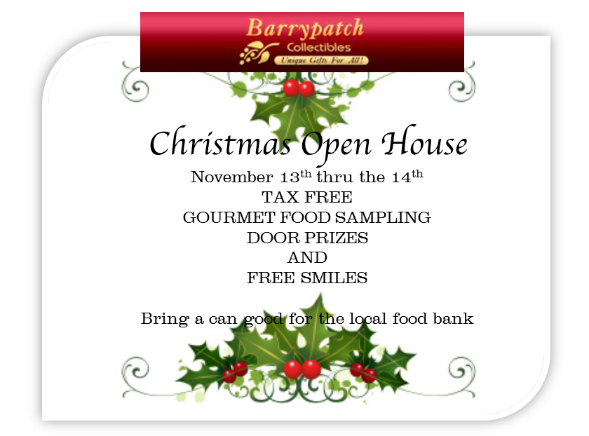*

Also:

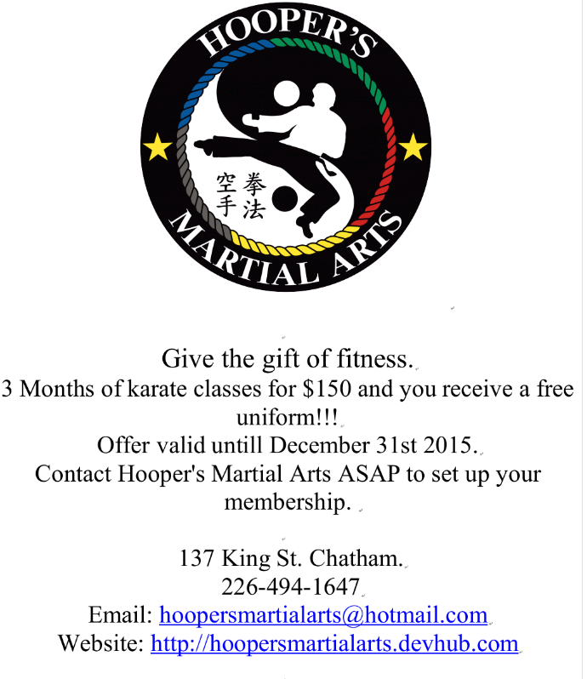<https://www.facebook.com/Retrofest>